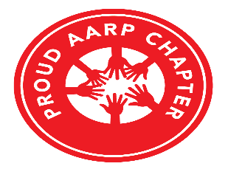AARP Suitland, Maryland Chapter #939 Scholarship
Application Requirements (2022)
Introduction:
The AARP Suitland, Maryland Chapter #939 Scholarship offers funding opportunities for graduating high school seniors. If you plan to enroll in an accredited college/university or accredited vocational school as an undergraduate student this year, you can apply for an AARP Suitland, Maryland Chapter #939 Scholarship.
Eligibility Requirements:
Students must meet the following criteria:
- Must live in Prince George’s County and graduate from a Prince George’s County High School;
- Applicant’s Sponsor must be a member of AARP Suitland, Maryland Chapter #939;
- Applicants may have participated in extracurricular and/or community activities;
- Provide proof that applicant is accepted into an undergraduate or vocational academic program and;
- Must graduate in academic year 2021-2022;

Application Process:
To be considered, all applicants must submit an application package that contains the following documents:
- Application Form
- Essay, 2 pages typed in double spaced and size 12 font
- Academic high school transcript
- Letter of reference from a Teacher, Minister, Or School Counselor
- Required Signatures
- College/University/Vocational School Acceptance Letter(s)
- Photograph with Signed Release Form, ((Please print name on back of photograph. The photograph will not be returned)

The application package must be postmarked no later than Friday, May 13, 2022, and mailed to:

Sharon Calhoun, Chairperson
Scholarship Committee
AARP Suitland, Maryland Chapter #939
P. O. Box 471465
District Heights, MD 20753
SELECTION PROCESS:
The AARP Suitland, Maryland Chapter #939 will consider only completed application packages and envelopes must be postmarked with U.S. postal stamp by the Friday, May 13, 2022 deadline. Written notification of awards will be sent to you by Friday, June 3, 2022. Monetary awards will be forwarded directly to the school or university upon proof of enrollment and registration for the Fall Semester of 2022.
Thank you for your interest and participation.

_Sharon Calhoun__________________________
Sharon Calhoun, Chairperson
Scholarship Committee

Catherine Williamson
Catherine Williamson
President

