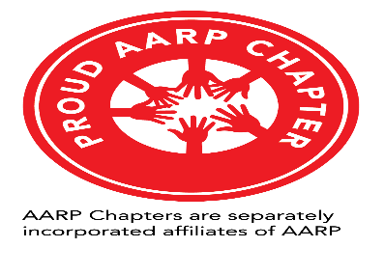

PHOTOGRAPH PERMISSION AND RELEASE

I hereby give the AARP (hereinafter referred to as the “Association”), the absolute and irrevocable right and permission, with respect to the photographs that it has taken of me, or in which I may be included with others, to use, reuse, publish and republish the same, in whole or in part, individually or in conjunction with other photographs, in any medium and for any purpose whatsoever, including (but not by way of limitation) illustration, promotion and advertising and trade.

I understand that I will not have any right of approval or receive any compensation as a result of any such use or re-use of my appearance in the photographs. I hereby waive any rights of privacy or publicity that I may have with respect to the photographs and any use or re-use of the photographs. I release and discharge the Association, its affiliated companies, and its licensees from any and all claims and demands arising out of or in connection with the use of the photographs, including, without limitation any and all claims based on rights of publicity or privacy, or for libel.

This authorization and release shall also ensure to the benefit of the legal representatives, affiliates, licensees and assigns of the Association as well as the person(s) for whom took the photographs.

I am under twenty-one (21) years old, my parent or legal guardian has consented to the terms of this release on my behalf.

___________________________________
Signature

___________________________________ ______________________
Signature – Parent/Guardian Date

_____ ______________________________ ______________________
Print Name Date

